Richfield Historical Society Box 268 Richfield, Wisconsin 53076 Richfield Historical Society.org


President Vice President Recording Secretary Corresponding Secretary Treasurer Past President
Joni Crivello Mary Kokan Katie Waln Mary Kokan Lois Hessenhauer Pete Samson
Directors Linda Aicher Dan Jorgenson Doug Maschman George Piontek Eva Tuinstra Nate Walters
Committees Blacksmith Shop Jeff Beegle/ Kathy Lauenstein
Collections Deanna Einwalter
Education Kathy Weberg
Events Coordinator Daryl Grier
Historic Sites Quint Mueller/Herb Lofy
Library/Newsletter Marge Holzbog
LWC Welcome Center Ruth Jeffords
Marketing Doug Wenzel
Membership Dorothy Marks
Mill House Tonya Kleppin
Mill Restoration Al Mayer
Pioneer Homestead Susan Sawdey
Programs Connie Thoma
Project Coordinator Al Mayer
Volunteer Coordinator Sharon Lofy

Volume 28 Number 3

A Tribute to Richfield’s Agricultural Past
– by Susan Brushafer
Men, put on your work shirts, denim overalls, sturdy boots, and straw hats. Ladies, don your handmade house dresses, embroidered aprons, Oxford shoes, and headscarves! Let’s visit farming in Richfield from the early 1920s through mid-century.

.

As you drive through Richfield and appreciate its beautiful landscape shaped by corn fields, Holy Hill in the distance, scenic roads, horses and cows, you’ll pass farms. Many are older than you (yes you, too) and are well kept testimonies to the families that built our village.
Many of you reading this are descendants of early farming families; some of you still live on the lands your great-grandfathers and great-grandmothers called home.
In almost any conversation at a Historical Society event, you’ll hear mention of heritage family names linked with snippets of ‘remember when’ and ‘remember where’ as friends chat about the good ol’ days.
Before looking at farm machinery, let’s touch briefly on what you’d have found on a Richfield farm.
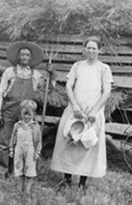

Typical Farm Family

Farm Crops and Animals Rural American 1920s
On a typical Richfield farm, you w
Farm Crops and Animals
On a typical Richfield farm, you were likely to find basic field crops like barley, rye, and oats. Barley provided good food for cows along with high-fiber Timothy hay and alfalfa. Although we probably notice corn fields more than other crops, in the early 1920s, not too much corn was grown. Hybrid grain crops, those created by cross-pollinating two inbred parent strains to combine desirable traits and increased productivity, had not yet been introduced.
That meant farmers had to be vigilant regarding pests, diseases, and climate conditions. Other crops included sugar beets, a short-lived crop, and carrots and peas for canning.
Multi-faceted farms kept livestock like cows, chickens, hogs, and poultry. Farmers worked hard to maintain their families’ food independence.
Processing Crop Yields
“Susie, grab a bag of frozen corn from the freezer.” “On your next trip down to the basement, Bob, bring up a jar of sauerkraut and a can of pickled beets off the storage shelf.” Your mom may have requested this cooking help from you when you were a child. For years, we’ve stocked our shelves with processed foods purchased at the local grocery store. In the 1920s, your great-grandma would have enlisted your help with corn shucking, fermenting cabbage in stoneware crocks, and gathering the vinegar and salt for pickling red beets! (Note: stop by the General Store in RHS’ Welcome Center to see an original stoneware crock!)
On the Richfield farm, red beets and peas were taken for processing to the Hartford Canning Company, founded in 1905 and acquired by Libby, McNeill & Libby in 1930. In fact, the original Hartford Canning Company building now houses the Schauer Arts Center and Wisconsin Automotive Museum. Canneries provided farmers with a consistent buyer for their cash crops, reducing market uncertainty. Farmers could count on selling their harvest, which encouraged larger-scale planting. Farmers would use a large ton-and-a-half truck to haul red beets to canneries. That same truck was often used on the farm as a forage wagon. Jackson, Rockfield, Sussex, and Hartford had canning factories. Beets were loaded on rail cars in Menomonee Falls for shipping to various other processing plants.
A Grateful Thank You
Your article’s author had the privilege of talking with Herb Lofy, whose family farm is located across from the Richfield Historical Park off of Pleasant Hill Road. The goal was to tap Herb’s experiences regarding farm equipment. As a member of a Richfield heritage family, Herb provided a wealth of information, which is woven into this article. He also shared personal stories and cited the names of equipment dealers in the neighboring communities. During the discussion with Herb, his friend Travis Krueger stopped by and was invited to chime in with additional recollections. Travis’ great-great grandma was part of the Messer family. The Messer family’s long-standing presence in Richfield included involvement in farming. They owned a farm in Richfield, and one in Erin, a neighboring community.
Thank you, Herb and Travis!
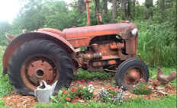
Rustic Tractor Decor
Farming Equipment … An Evolution
Many types of equipment were used on the early 20th Century Wisconsin farm. In our drive around Richfield, it’s not uncommon to see a piece or two of old equipment proudly displayed in a farm’s front yard. While books have been written on the various types of farming tools and equipment, we’ll look at some of the machinery on the Richfield farm.
Later in the article, you’ll find a list of equipment you’ll be able to explore at the Richfield Historical Society’s 2025 Thresheree!
Prior to the mid-1800s, Wisconsin farmers relied on the horse-drawn plow. Teams of draft animals, especially horses and mules, pulled plows, harrows, seeders, and wagons. Horse-drawn methods were labor-intensive and limited by the stamina of the animals and the physical endurance of the farmer.
Development of farming equipment continued, and one of the largest innovations was the use of steam-powered machines. Steam engines, first developed in the late 1700s, were applied to various pieces of farming equipment by the early 1800s despite their substantial weight (some over 18,000 pounds!). They were especially useful for threshing and field work.
By the late 1800s, J. I. Case was one of America’s largest builders of steam engines, traction engines, and steam-powered threshing machines. After initially settling in Rochester, Wisconsin Territory in 1842, Case moved to Racine in 1844. Case’s equipment helped mechanize farming and reduced reliance on manual labor. Case held a large share of the equipment market.
How important was the steam tractor? Tyler Roudebush, Waunakee, Wisconsin farmer and restorer of a 1922 Minneapolis steam engine stated: “These tractors were cumbersome to drive and not suited for small farms. They were used to pull implements or provide stationary power for threshing machines and feed mills.” Their success continued through the mid-1920s. With the development of the internal combustion engine, steam took a back seat.
Herb Lofy shared that the property next to the Messer/Mayer Mill, owned by Paul Ramthun (1889-1950) had a steam engine and threshing machine. Herb’s great uncle farmed just north of Lofy’s property off Pleasant Hill Road. The uncle’s son wrote memoirs of growing up in Richfield. Before his father died, he asked his boys to get his steam engine and threshing machine so that he could once more see them!
Internal combustion engines are engines where fuel is burned inside the engine itself to produce power. Think of your car when you fill up with gasoline, diesel, or flex fuel. The combustion pushes pistons, which turn a crankshaft and generate motion. The first successful gasoline-powered tractor was built in Madison, Wisconsin in 1901 by Hart and Parr. Called ‘Old Number One’, it weighed five tons, pulled five plow bottoms, and was supported by huge, cleated tires made from wood. The term ‘tractor’ was coined by Hart and Parr in 1903!
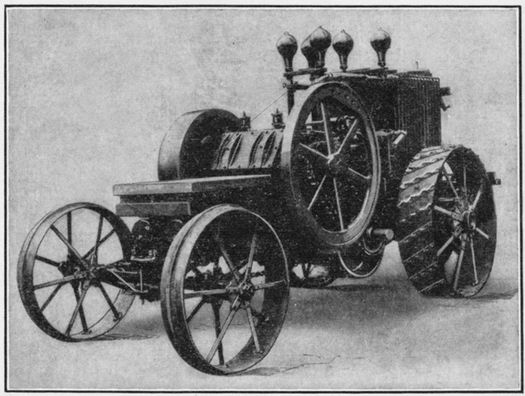
Hart-Parr’s ‘Old Number One’ 1901
An aside … how affordable were the equipment innovations? Farm machinery was and still is expensive. A Hart-Parr tractor was a hefty investment. That would be equivalent to over $70,000 today.
Dairy farm neighbors would share equipment like manure spreaders, tractors, and bailers. Neighborly camaraderie was especially important during threshing season. Depending upon the model type, a John Deere sub-compact to mid-sized tractor purchased in 2025 can cost between $15,000 to $60,000. Large horsepower tractors (est. 400 HP) can cost $1,000,000+. These, of course, include cutting-edge tech with GPS and Artificial Intelligence systems.
Over the years, of course, farm implements evolved into what they are today – fantastic time-saving machines. Herb Lofy shares a story from his life on Lofy’s Richfield farm.
As a small child, Herb’s Dad had International Harvester tractors and one Ford. In 1961, Herb recalls seeing John Deere literature on the table. The brochure featured a beautiful picture of the John Deere 8010. It was part of Deere’s “New Generation” launch, marking the end of the two-cylinder era. Herb noted “things transitioned to John Deere – non-denominational, plusses-minuses, (there was) no perfect manufacturer.” The first tractor he can remember on the Lofy farm was a John Deere 4010.
His father believed in updating equipment and used the 4010 for a year. He then wanted bigger tires. The 4020 models changed the next year, and his Dad bought a 4020 from an implement dealer in Watertown. He purchased his last 4020 in 1970.
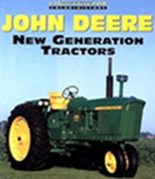
Herb recalled a dealer in Hartford, Freehauf Implement, which bought out Hogge & Gumm in Jackson. They had a John Deere franchise from the early 1900s. Lofy’s Dad also did business at a St. Lawrence garage, now called St. Lawrence Equipment.
Herb shared a memory about the then latest farming innovation.
1958 Select-O-Speed Ford Tractor
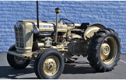
In 1958, his Dad had come home for dinner talking about the ‘Select-O-Speed Transmission’, introduced by Ford. It was marketed as a full power shift transmission. Here are Herb’s Dad’s words about this new technology?
New Generation Tractor r
“If you can’t shift the tractor, you shouldn’t be driving it!”
Herb noted “Dad eventually got with auto transmissions.”
Prior to and through World War II, farmers needed more equipment to do the work. This precipitated major tractor design leaps, especially in the 1940s-1950s. Instead of waiting for manufacturers to catch up, however, farmers and machine shops got creative. Farmers began coupling two tractors, often John Deer A’s, R’s, or 820s into a single articulated unit (one machine that can pivot or bend). These were often homemade ‘tandem builds’ -- setups that used steel frames and hydraulic systems to sync between front and rear tractors.
Harvester World Magazine (1909–1969) often featured innovative farm solutions, including tandem tractor experiments and user-submitted modifications. Interested in knowing more? The Wisconsin Historical Society archives in Madison offer a rich collection of Harvester World issues.
Dealers
Where did a farmer go to purchase a 10-ton tractor for the family farm? Herb Lofy noted that most farm equipment dealers and distributor were “offshoots of blacksmith shops.” He shared that some of the local dealerships are still in business, including:
Strupp Implement in Slinger. In November 1946, Sylvester Strupp purchased the business from William Langenecker. It was originally an Advance-Rumely dealership. Strupp ran it as an Allis Chalmers and Massey Ferguson dealership. Today, it is a New Holland dealership with several short lines included.
St. Lawrence Equipment in St. Lawrence. This business started as Laatsch Implement selling Ford tractors and Dearborn implements. The business was purchased by Mr. Laatsch's son-in-law Lyle. Schultz and partner Harold Hefter in the early ‘50s. Laatsch also sold Belle City threshing machines. Today, it is a New Holland dealership with several short lines. It’s owned and operated by Mr. Schultz's sons, Randy and Mark.
Farmers Implement in Alletown. This Case International Harvester dealership dates back to its founding as an IH store in 1913. It originally opened as a farmers' cooperative known as Farmers Mercantile Exchange. There is now an additional dealership in Columbus, WI. The business is owned and operated by the Kreilkamp family.
Lochen Equipment in Newburg. The business was started in 1899 by the Lochen brothers. It was an International Harvester and Ford vehicle dealership for many years. Now, it’s a Kubota dealership with multiple short lines. A second location was added in 2023 in Waldo, WI. The business is still owned by the Lochen family.

Many of you will feel nostalgic if you remember or recall your parents and grandparents talking about the following. These businesses, once staples of the Washington County community, have since faded from the landscape.
Dealership | Location | Equipment Line
Ardell Schmidt | Richfield | Surge milking equipment
Butzke | Jackson | International Harvester, Gehl; became Jackson Equipment in early 1970s
F&I Equipment | West Bend | Ford tractor/implements
Forester Implement | Wayne | Oliver
Freehauf Implement | Hartford | John Deere; bought out Hogge & Gumm, Jackson, WI
Kohn Brothers | Kewaskum | Massey Ferguson
Myron Perschbacher | West Bend | Gehl, New Idea, Allis Chalmers tractors/implements; business located north of current Mueller Furniture; business closed in 1974; Myron passed in 1977
P.A. Mueller | Hartford | International Harvester
Rosenheimer Hardware | Kewaskum | John Deere
Weiss Hardware | Allenton | J.I. Case

Red-E Tractor?
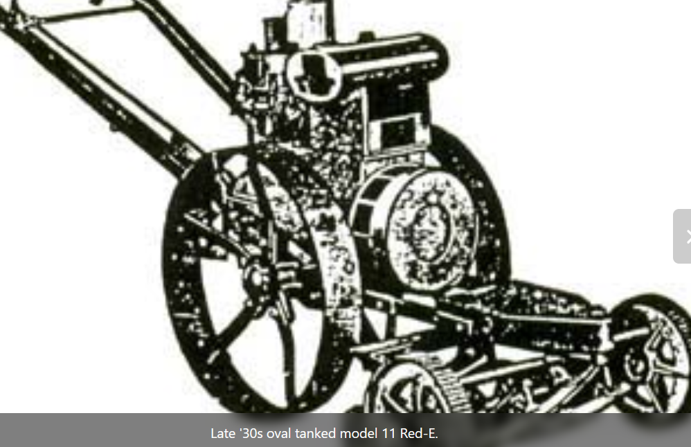
Late 1930s Oval Tanked Model 11 Red-E
Here’s a final piece of farming nostalgia.
The Red-E tractor was originally developed in the early 1920s in Milwaukee. In 1927, the company built a factory in West Allis, WI, producing what was then called the Pioneer RED-E Power Cultivator.
By 1946, the company moved its operations to Richfield, WI (1946-1988), and officially became the RED-E Tractor Company marking Richfield as its manufacturing home.

Keep the Memories Alive
Take that drive through Richfield. Notice the grazing cows, the golden cornfields, and the silhouette of Holy Hill rising in the distance. Now, look again. Pull to the side and enjoy a moment to enjoy those barns, silos, and tractors tucked into our community’s landscape. They represent living chapters of our village’s story. Keep the memories alive!
President Joni Crivello
Dear Members and Friends,
As summer begins to wind down and we reflect on another meaningful year for the Richfield Historical Society, I wish to express deep appreciation for the individuals who continue to bring our mission to life. Each of our volunteers and members who support RHS are invaluable.
At our August 6th Recognition Picnic, the results of the all-member nomination process for recognition categories were announced. I am honored to share the recipients of this year’s recognition honors. These individuals have given generously of their time, talent, and passion, helping us preserve and share the history of Richfield with the community.
- Bob Laubenheimer – Homesteader Recognition
The Laubenheimer family has deep roots in Richfield. Originally named Laubenheim, the town was founded by Johann Philipp Laubenheimer. Bob is a longtime, dedicated member of the Thursday crew and RHS member.
- John Schmidt – Craftsman Recognition
For his significant contribution of his woodworking talent which can be seen throughout the Historical Park and buildings. The garbage can containers, Cooney Creek sign, and Welcome Center handicap ramp are just a small sampling of his work.
- Lavern Schmitz and Charlie Schmitz – Volunteer Recognition
This father and son have been critical partners to the Society in countless areas for many years. They have a dedication to preserve and promote the past by providing equipment and demonstrations for RHS.
- Jim Metzger – Lifetime Achievement Recognition
This lifetime member has held multiple leadership positions. Jim’s strong support for RHS has led to positive changes within our organization. His encouragement and contributions continue to help advance our mission and vision.
- Kathy Weberg – Member of the Year Recognition
Serving as the Chair of the Education Committee, Kathy provides opportunities to discover history to the young and old alike. Her selfless efforts and increasing outreach with education days, tours, and the traveling trunk make history available to thousands who may not otherwise be exposed to our collections.
- Al Mayer – President’s Recognition
This member inspires us all with his dedication. Chair of the Mill Committee and running the Thursday crew, his hard work and mechanical knowledge is priceless. Take a look at the RHS buildings and grounds, the Thursday crew is responsible for the well-maintained condition with him at the helm.
Each of these honorees represents the heart of what we do: preserving history, educating others, and building community. We thank them—and all of our volunteers—for their efforts.
As we look ahead, I encourage each of you to consider how you might get more involved with our historical society. Whether it’s helping out at an event, assisting with preservation efforts, serving as a board member, or simply sharing our mission with neighbors, your contribution matters. No action is too small when it comes to keeping our shared history alive.
If you’ve been a member from afar or haven’t yet found your place within our activities, this is a wonderful time to take that first step. We’re always looking for new ideas, fresh energy, and willing hands.
Thank you for being part of the Richfield Historical Society. Together, we honor the past—and shape the future.
Warm regards,
Joni Crivello
Blacksmith Shop _______________ _Jeff Beegle/Kathy Lauenstein
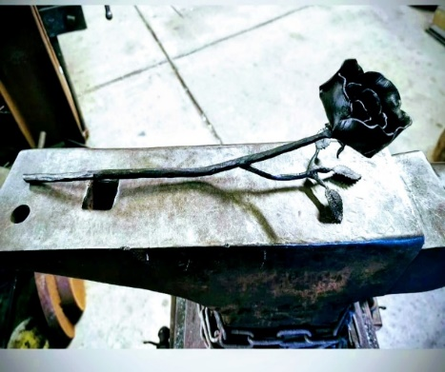
Jeff Beegle – The art of Blacksmithing has progressed over the years but Blacksmiths still play important roles today, though their work has evolved significantly from traditional iron-forging for tools and weapons. Here are some modern ways blacksmiths contribute today:
1. Artistic and Custom Metalwork
- Sculptures and Art Installations: Many blacksmiths create decorative pieces for homes, gardens, and public spaces.
- Architectural Elements: Custom railings, gates, door hardware, and lighting fixtures are often handcrafted by blacksmiths.
- Restoration Work: They help restore historical buildings and artifacts by replicating period-accurate metalwork.
Decorative Item

2. Tool and Equipment Fabrication Custom Tools: Blacksmiths make specialized tools for woodworkers, leatherworkers, and other craftspeople.
Agricultural Implements: In rural or off-grid areas, blacksmiths may still forge tools and repair equipment.
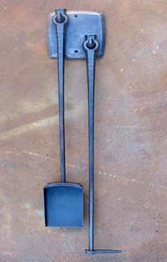

Tool and Equipment Fabrication Custom Tools: Blacksmiths make specialized tools for woodworkers, leatherworkers, and other craftspeople
3. Education and Heritage Presentations
- Teaching: Many blacksmiths run workshops or classes to pass on traditional skills.
- Living History demonstrations: They participate in reenactments and museum exhibits to showcase historical techniques.
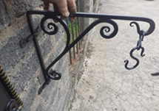
Agricultural Implements: In rural or off-grid areas, blacksmiths may still forge tools and repair equipment.
3. Education and Heritage Preservation

3. Education and Heritage Preservation
Useful Tool
Custom Item

4. Knife and Blade Making
- Custom Knives and Swords: There's a strong niche market for handcrafted blades, often combining artistry with functionality.
- Cutlery and Culinary Tools: High-end chefs often seek out blacksmith-made knives for their quality and craftsmanship.
5. Industrial and Functional Metalwork
- Prototype Development: Blacksmiths sometimes assist in creating prototypes for mechanical parts or tools.
- Repairs and Fabrication: In some industries, blacksmiths help with custom repairs or fabricating parts that aren’t mass-produced.
Please stop out to the Richfield Historical Society Blacksmith Shop during our up-coming events and say hello. We look forward to seeing you in the future.
Collections Deanna Einwalter
MEDICINE BOTTLES IN THE EARLY DAYS

Back in the 1800s, medicine was mainly stored in colorful glass bottles—some prescription and some over-the-counter.
Recently, we uncovered a few of these bottles buried near the Mill House! One of them contained sodium iodine, which was commonly used to treat thyroid issues or ailments like syphilis and skin problems.
We’d love for you to come visit our buildings and explore all the fascinating artifacts we have on display!
Medicine Bottle
Education Kathy Weberg

RHS is the recipient of an item which will reside in the Messer-Mayer Mill to further the authenticity of life in the late 1800s and early 1900s. A spitoon! We thank Bud and Joan Moertl for this special contribution.
Spitoons were typically made of brass or porcelain and are also known as cuspidors. This donated spitoon is brass and weighs five pounds!
Spitoons were present in the late 1800s in banks, pubs, brothels, saloons and other public places. The use of spitoons declined in the 20th century as chewing gum became more available. Boy Scouts took on a mission of curtailing spitting as a very unsanitary practice. (Really!!)
Spitoon
Smoking in a Grist Mill would be strictly taboo. Grain dust is highly flammable and explosive which could lead to a very quick and destructive fire. This would have carried over to any farm as hay storage in barns could lead to a hugely damaging event if the hay would ignite. While I'm making certain assumptions, I believe the gentlemen who frequented the Mill for grain-grinding purposes no doubt stopped to have a chew with their friends as they connected socially. In fact, on the back of one of the doors in the Mill, a written reference is made just to that effect. So it would be appropriate to have a spitoon handy.
Events Coordinator Daryl Grier
Richfield Days
The Events Committee has been working on Richfield Days where we sold “walking tacos”. Since we have never done that before, we have been determining what we needed to make them and how the booth will be laid out. You will be able to see how well we did since you’ll get this newsletter after the event. We always make notes on what we could improve for next year. I’m sure that you have seen that with other events.
We don’t have a date for our next meeting ; however if you have any suggestions for upcoming events, contact me at 262-628-4221 or dgrier@charter.net

Thresheree
PLEASE REMEMBER: NO RUMMAGE THIS YEAR!
Sweets ‘n Stuff
Your fabulous baked goods will be sold at the Sweets ‘n Stuff Thresheree Tent. You will receive an email where you can access a sign-up sheet. If you don’t have email, please call me. We need cookies, bars, brownies etc.
Note:
- 2 cookies to a bag

    - 1 brownie or fudge, about 3” square to a bag

Please mark whatever container that you bring them in with the general ingredients, e.g., oatmeal raisin, ginger snaps, etc. as visitors ask what they are. Drop your sweets off at Daryl Grier’s, 1179 Wejegi Dr, or bring them to the Thresheree on Saturday or Sunday A.M.
Silent Auction: We still need silent auction items. They should be either new items to be added to a basket or a basket with new items. Please contact Deloras Parsons with questions (414) 852-3733 dapars1956@gmail.com
RHS’ Beautiful Gardens
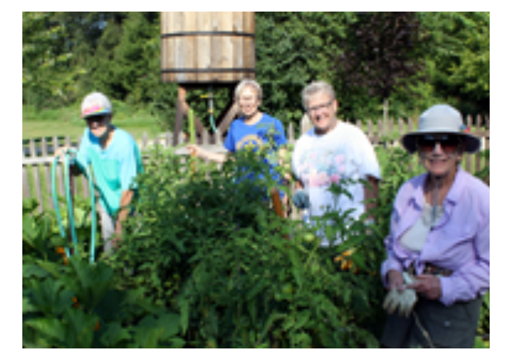
The Vegetable Garden:
We have a great volunteer team who work in the RHS vegetable garden. Ed Kyle provides beautiful tomatoes.
If you would like to share the produce, contact me and join our team! 262- 628-4221 dgrier@charter.net
Flower Gardens:
Master Gardner, Laura Staton, is doing a lot of work fixing up many of our flower gardens.
Some examples include adding annual plants in several places to add color, adding plants in front of the Welcome Center and adding flower barrels in front of the Log House & Mill House.
Garden Workers Daryl Grier, Chairman (on right)
We will be planting high-fiber native plants in the gardens this Fall and in the future.
ART AT THE MILL JUNE 21, 2025 – Linda Aicher (Art Fair Chairman)
It was an event visitors and artists wait for all year. The hot, breezy summer day was not going to hinder most artist and visitors. Some visitors took the tractor ride while others decided to take a leisurely walk to the fair area. Visitors were treated to beautiful unique items at this year’s fair including paintings, jewelry, felted soap, pottery, wood creations, yard art, ceramics, leather products, glass art, photography, flower pots, chain saw carvings and many others artist creations. Also available were nuts, jams, jelly and baked goods.
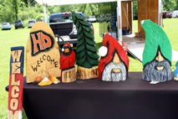
A place to take a break from shopping and the heat was to enjoy the Mill House with self-guided tours or the air-conditioned Lillicrapp Welcome Center displaying a General Store and History Room. The Messer/Mayer Mill was also open. Some choose to enjoy the breeze while searching for their special silent auction item.
Wood Creations
Delicious food was provided by Richfield Lions which could be enjoyed under the tent while listening to soothing music provided by VIVO. Enhancing the food, Belshire Brewery had their craft beer and seltzer available. Soda, water, and refreshing ice cream was also enjoyed by many. After shopping, touring the buildings, eating, satisfying your thirst you could stop at the Blacksmith Shop for a demonstration on the way back to your vehicle.
This fabulous event could not happen without the talented, dedicated Thursday crew, many wonderful volunteers, Richfield Lions providing the food, Belshire Brewery providing beverages along with the talented artists, vendors and visitors.
Thank you too all!!!!! Mark your calendar for Art at the Mill June 20, 2026
Historic Sites Quint Mueller/Herb Lofy
In past newsletters we’ve talked about the Mill and Barn roofs. I’m happy to report that both roofs are now complete and the new gutters are being installed at the time of this writing. With the new roofing and gutters, these roofs should be good for many years to come.

There has been some concern voiced regarding the shiny new gutters and that they are not appropriate (too fancy) for the nature of the buildings in our park. To be perfectly accurate, the buildings didn’t have gutters at all. Adding gutters was a decision made to help preserve the buildings. Water running off the roofs and landing close to the buildings adds significantly to the deterioration of the foundations and even the siding when the rain water splashes up. For this reason, adding gutters to historic buildings is well accepted as a necessary exception to historical accuracy to help preserve the buildings. That is not addressing the original issue, though, the shiny gutters. Just under a year ago the Mill House roof was completed, including the same shiny gutters. This is when the comments started to be circulated.
Mill House Gutters (Installed Fall of 2024)
Fast forward to August of 2025 and those same gutters have now developed a nice dull patina. The two photos in this article were taken the same day, one of the house gutters and one of the new barn gutters. The only difference between the two is just under a year of weathering. I think you will agree, after a little aging, the “new” gutters fit in quite well with the Messer/Mayer buildings.

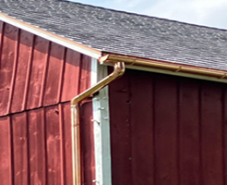
The next roof project is moving forward. After several attempts that were blocked by mother nature raining out the crew, as well as other events, we finally were able to get the main Granary roof stripped, sheathed, and covered with underlayment. At this time, the Thursday crew is working to install the new metal roofing. By the time you read this, we’re hoping to have the main Granary roof complete and water tight again. Once that’s done, we’ll move onto the Granary lean- to roof. That roof is badly in need of replacement. Some of us learned that during the last attempt to remove the existing roofing on the main roof. We took shelter in the lean- to when the rain started to pour on us, only to find out it was raining inside the lean- to as well.
Barn Gutters (Installed August 2025)
The roofing projects are still the main focus of this season. Of course, there are still the never ending maintenance projects of a park with historic buildings. The RHS crew’s project list is long and never done.
Even though some of these projects can be a lot of work, they end up being enjoyable, and maybe even fun along the way. Take a look at Al Mayer’s article about the Thursday crew elsewhere in this issue to see what a typical Thursday work day is like. Maybe you would like to join them!
Library/Newsletter Marge Holzbog
Mary Kokan -

The Welcome Center at the Richfield Historical Park has some very special activities planned for the Thresheree.

- Our new digital history kiosk will make its debut and will be available for visitor use in the History Room. Here, visitors will be able to find a collection of photos and histories of many of the homestead families of Richfield with a touch on the screen.

- A display of photos showing a street view of homes in the village taken during the 1980s.

- Calligraphy demonstration outside, under a tent on Sunday only.

- Historic outdoor children’s games that invite participation of children and their parents on the front lawn of the Welcome Center on Saturday and Sunday from noon to 4:00 P.M.

- Live music by singer songwriter Rick Kokan. Rick’s original music recorded on 8 CDs fits into the folk / rock genre and he covers songs of Jimmy Buffet, Gordon Lightfoot, Jim Croce, James Taylor, Bruce Springsteen and John Denver. You can find his music on You-tube, Spotify and other online platforms. He will be performing under the flag pole both Saturday and Sunday afternoons from 1:00 - 3:30 pm.

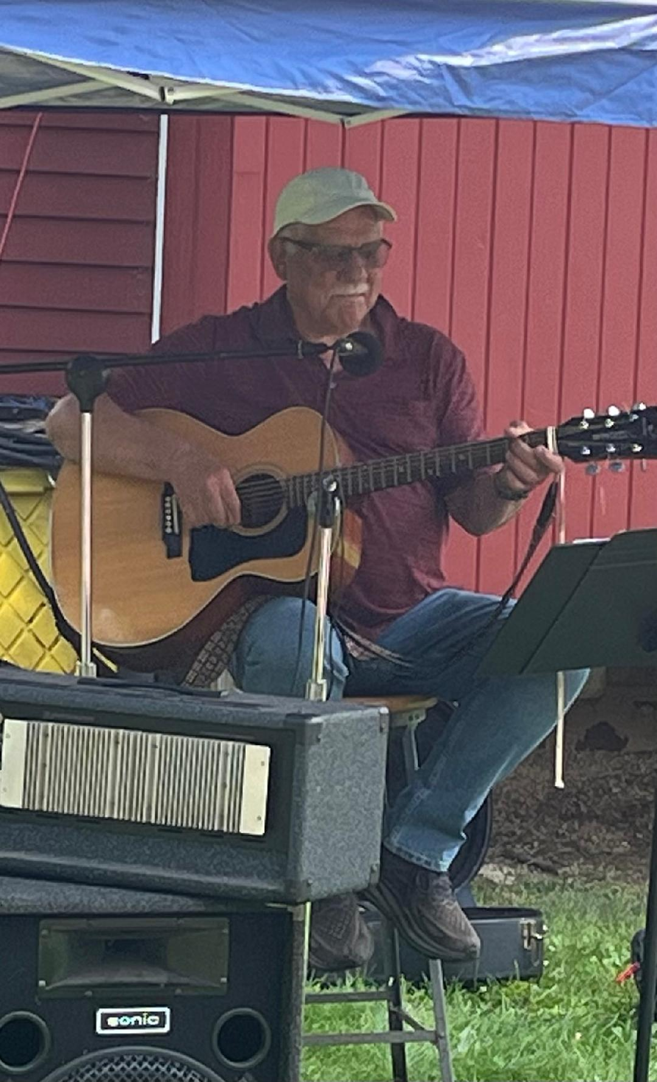

Rick Kokan

- Live music by singer songwriter Rick Kokan. Rick’s original music recorded on 8 CDs fits into the folk / rock genre, and he covers songs of Jimmy Buffet, Gordon Lightfoot, Jim Croce, James Taylor, Bruce Springsteen and John Denver. You can find his music on You-tube, Spotify and other online platforms. He will be performing under the flag pole outside the Welcome Center both Saturday and Sunday afternoons from 1:00 - 3:30 P. M.

LWC Welcome Center Ruth Jeffords
COME AND SEE THE OLLAS AT THE LWC!

And no, they are not flowers or birds . . . but actually a form of irrigation. Ollas (pronounced ohh-yahh) are unglazed, terracotta clay pots that were first used for irrigation over 4,000 years ago in North Africa and China. Marge Holzbog introduced us to this new/old irrigation system which she uses to maintain the herbs planted in wooden barrels along the LWC east walkway.
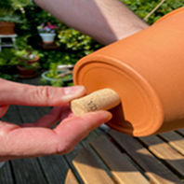


And through the dedicated efforts of our volunteer Master Gardener Laura Statten, there’s a lot to ooh and aah about: new flowers mixed in with the old, and many “ollas” around to help with watering. This is especially significant for us since there is no running water in the Park – just a small rain barrel and a creek for scooping up water.
Olla in the Garden
Olla

Research has shown that subsurface watering from clay ollas is 10x more efficient than conventional irrigation; not to mention ollas conserve water during periods of drought.

An olla can be a simple open terracotta pot planted in the ground (well into the ground so only top edge is exposed) and filled with water (making sure the bottom hole of the pot is closed off with a cork) and then cover it. Gradually, and only as needed, the water seeps out through the pores of the terracotta and feeds the roots of the plants nearby. Over-watering is eliminated with this method. You can also purchase ready-made ollas from Amazon or other places.

Marketing Doug Wenzel
Speaking of press releases, I’ve found an unexpected benefit to the RHS picture vault. In the past, I’ve attached a few pictures with each press release that I sent out. This year, instead of picking just a few pictures, I’ve been including with the press release a link to the pictures vault, allowing the news organizations to select their own pictures. This has worked out very well.
We do need to keep the vault fresh. Do you have pictures from this year’s Maple Syrup Family Day, Education Days, or Art at the Mill? If so, please contact me and I’ll send you instructions for copying them into the vault, or get them to me so I can do it. Thanks for your support!
Membership Dorothy Marks
For the upcoming Thresheree, we will again have our boutique at the Horse Shed. We will be featuring beautiful handicraft items provided by our many talented Richfield artisans. Stop by to see if one of the beautiful items could find a special place in your home or as a gift for a very special person.
Speaking of horse sheds, in the early days of farming horse sheds served important purposes for both the horses and the farmers. Horse sheds offered refuge from harsh weather conditions such as rain, snow, wind and extreme heat or cold. During hot weather, the shade provided by the shed made temperatures feel cooler preventing overheating of the horses. Sheds also protected horses from the flies and other biting insects which thrive in hot and humid conditions. Sheds provided shelter in cold months to conserve body heat and reduce the risk of unsafe drops in body temperature. Well- designed sheds allowed horses to enter and exit freely giving them a choice of seeking shelter and also promoting their grazing and social behavior. A well designed shed provided enough room for horses to graze and rest under cover. In some cases, sheds with partitions could be used to control individual horses access to pasture or to separate horses for feeding purposes. Some sheds were designed to serve multiple purposes such as storing hay, feed and farm equipment. Sheds were also attached to or near corrals or fences affording the farmer easier access for managing the horses.
Horse sheds were valuable assets in early farming contributing to the health and productivity of the horses while offering storage and management solutions for the farmer.
Mill House Tonya Kleppin
Now Mostly Forgotten, Root Cellars Were Once Fundamental to American Settlers by Rose Heichelbech
In the book “Farmer Boy,” Laura Ingalls Wilder describes the vast quantities of food needed to sustain Almanzo’s large farming family, and storage in the root cellar was crucial to that effort. Keeping foods in the root cellar was the most efficient way to store foodstuffs, and once upon a time root cellars were fundamental to settlers and farmers across America.
Root cellars can be under the house or a separate building, but either way they were of great importance to many families from colonial times all the way up until World War II.
Root cellars were not a hugely common feature of many houses in England, so when the settlers came to America, they discovered they needed to be much more proactive about their food storage in the more-humid climates they now called home. Colonial New England homes were often outfitted with storage space below ground, and the tradition became common across the country by the time of Westward expansion in the 1800s.
Some root cellars were also storage for other goods or even wash rooms. Other root cellars also served as storage for animal feed as well, though the sheer volume of feed needed to feed the livestock through the winter would necessitate a huge space.
Generally speaking, building a root cellar implied you planned to stay where you were for a while, so many settlers did not have them. But, for those who lived in sod dugout houses built into banks or hills, the home was partially underground anyways and might have been of suitable temperature.
During the Great Depression and WWII, the Office of War Information and the Farm Security Administration encouraged people to “put up” foodstuffs and use their existing root cellars or even make new ones. They were encouraged to waste nothing and that meant keeping food as fresh as possible for as long as possible.
While the ideal for many farmers would have been that meat, dairy, vegetables, and fruits should be kept in separate spaces, most folks did not have that luxury and had to store their foods together. Apples are said to spoil other foods more quickly, but in a cold enough environment, kept in baskets, the apples can be safely stored with root vegetables and other foodstuffs. The ideal root cellar is at least 4 feet below ground level and is continuously cooler than 45 degrees Fahrenheit.
Prevailing wisdom on how to store things usually went something like this: garlic and peppers hanging, beans dried and strung (hanging) or canned, potatoes in piles together (sometimes buried in sand), apples in bushels, and cured meat hung from hooks (often in a cloth bag if possible), other fruits to be canned as quickly as possible, with corn often hung to dry to be made into cornmeal.
Even those who didn’t farm often had storage in the root cellar, as most families couldn’t afford to pass up a barter of potatoes or apples or ham, and most people didn’t have a refrigerator until after WWII.
While it wasn’t easy to process all that food, it was very much needed to see them through long and harsh winters (and extremely useful for keeping dairy items fresh in the summer as well). As long as we have refrigerators, the root cellar probably won’t be making a comeback anytime soon, but this method of food storage was critical to making ends meet for scores of Americans for centuries.
I give credit to Author, Rose Heichelbech, Dusty Old Things.com, for this article that describes the history of storage in Root Cellars over 100 years ago.
This information has provided me with the resources I needed to stage the Mill House cellar at the Richfield Historical Park. This project presents an exciting opportunity to explore and contribute the idea to open the Root Cellar for future tours.
The current photos of the Root Cellar at The Mill House will be on display for your viewing at the upcoming events in this Fall.
Mill Restoration Al Mayer
One of the goals that any miller strives for in milling flour is to make the finest, most consistent flour possible. To achieve this standard, he would need to start the milling process with a grain that is as clean as possible. In the basement of the Messer-Mayer Mill is a machine designed to clean the grain kernel of all foreign matter before it enters the milling process. Built by Bernard & Leas in Moline, Illinois, the Separator- Smutter Grain Cleaner was installed, presumably when C.W installed the four- double roller mills as part of the renovation that was completed in 1894.
Separator-Smutter Grain Cleaner →
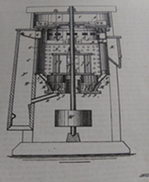

The grain that was brought to the Mill would arrive in various degrees of cleanliness. Between the dirt and dust that would accumulate while growing, or the amount of other plant growth (weeds) present in the field when harvested, these elements had to be removed before the milling process could begin.

This machine, which is located below the two hoppers on the first floor, where the grain is introduced into the Mill, was also designed to remove smut, which is a fungal disease that would infect the grain berries and had to be removed.
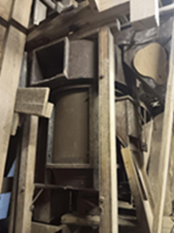
Basically, flowing air up through the grain while it's being agitated will cause the grains to clean against each other, and the air current will lift the lighter impurities to "float" off to be discarded. The use of fans, screens, and specially designed chambers would achieve the desired result of cleaning all impurities from the grain berries.

We've been able to acquire the patent diagram and description of this unique piece of equipment, which identifies each parts name, function, and purpose. This is one of the many pieces of the rare artifacts of equipment housed in the Messer-Mayer Mill, used over 100 years ago, still intact, and waiting to start functioning again when we're able to get power transmitted back into the Mill.

We would love to have you come out to the Park some Sunday, 10 A.M. -2 P.M.. and see what we're doing. Take a look at the many restoration activities that might interest you. Most projects are of a cleaning/detailing nature, all explore the art and craftsmanship of a bygone way of living.
Impurity Cleaner
Pioneer Homestead Susan Sawdey

PIONEER HOMESTEAD SOURDOUGH BREAD
INGREDIENTS ECTIONS

Ingredients
2 c AP flour 1 c active starter ½ c milk 1 tsp sea salt Olive Oil for cooking

Make the Dough Add sourdough starter, flour, milk and salt. Knead for a few minutes. Cover and rest for 2-4 hours (or overnight for long fermentation).
Divide and Cook Divide into 8 equal pieces. Flatten on floured surface to ¼ in. thick. Preheat skillet on medium. Add Olive Oil and cook 1-2 minutes per side until brown.

Programs Connie Thoma
We will resume our Community Programs in September on the 26th with Jim Buchholz. He has retired from the Wisconsin State Park System. He will be presenting all you ever wanted to know about Wisconsin State Parks.

Our October 23 meeting will be Professor Patrick Steele from Cedarburg telling us how life was during prohibition in Wisconsin.

I am excited to announce that Jessica Michna will be returning once again to entertain at our November 20th meeting. She will be portraying Mrs. Charles Dickens in an all new presentation. This is one you don’t want to miss.!!!!

Our Community Programs are held at the Fire Hall on Hwy 175 at 7:00 p.m. They are open to the public and free of charge. Complimentary refreshments are served.

Project Coordinator Al Mayer
Every Thursday at 8:00 in the morning, one by one, vehicles will begin moseying through the Richfield Historical Park, and find their way to the lawn below the Mill House. Out of each a man will exit and find his way to the Barn behind the Mill House. Many times he will find another making the same journey and visit with him along the way. By 8:15 or so, a group of 14 to 19 guys have assembled near the workshop area of the Barn and are conversing in small groups about differing topics and experiences they've had during the preceding week.

Soon, the topics change to discussions of the projects around the Park to be worked on that was sent to them in an email earlier in the week. Between them, they decide how many guys it will take to work on each of the projects at hand and the tools and what materials are needed to accomplish the weeks' tasks. Before long, there are 4-5 groups of guys in various areas of the Park, working on the many different tasks that have been listed that need attention. A little after 9:30, they'll start to return back to the Workshop and take some time to get back together and chat some more.

Each week they will take turns bringing different snacks and goodies to nibble on during this time to visit and re-evaluate the morning’s work. After a half hour or so, the group disbands going back to continue their earlier tasks, or start a new one if the prior is complete. Generally, we try to wrap things up around noon. Sometimes a project will go a little longer, sometimes shorter. There is no time clock to punch, and we just appreciate so much the time, talent, and consideration that this group of friends has formed over the years that mow, cut trees, trim, paint, saw, hammer, fix, and replace countless items that need attention.

If you would care to join in with this group of guys, maybe you'd like to learn a new skill, or maybe you could show these guys a thing or two; pay us a visit on a Thursday morning! We always appreciate a new face, and introducing new people to the Park is something we all enjoy. Give a call - 262-909-0129. Please leave a message!

Volunteer Coordinator Sharon Lofy
The grain bundles are shocked. The bundles will be ready for loading on the bundle wagons for storage until the Thresheree. Hope you have your calendars marked for September 20 & 21 for RHS’s 26th Annual Thresheree & Harvest Festival.
During this weekend, you will see the grain bundles threshed, log sawing and horse demonstrations. Tours of historic buildings will be given of the Messer/Mayer Mill, Messer/Mayer House, Lilllicrapp Welcome Center (General Store and Richfield historical information). The Boutique, Silent Auction, and Sweets & Stuff will be great places to check out. Be sure to have your pies entered at the pie tent before 10 A.M. Judging will be at 10:30 A. M. ( NO CREAM PIES – No refrigeration available). Gasoline engines, corn shelling, shingle making, antique cars, trucks, Gehl machinery and other exhibitors will be ready for viewing. There will be a Kid’s Zone, along with things to do near the Mill and a map to have stamped at areas around the grounds. Don’t forget to stop in for lunch at the Lion’s Food Tent, followed by a piece of pie, ice cream and a drink. Find a place to sit while eating lunch and listening to the music. There will be a tractor parade both days. Take a ride on the people mover and see what is new this year at the Pioneer Homestead (log cabin & log barn). The Maple Sugar Shack will be selling maple flavored cotton candy. Follow the pounding noise of the anvil and hammer to the Blacksmith Shop. Be sure to share this information with your family and friends.
You will be receiving an email listing areas that will need a helping hand during these two days. Hopefully, you can give us a helping hand. It’s a great way for teens to do their community time. Also, if you have a friend or family member that enjoys volunteering, let me know. Working with them would be a great way to spend volunteering time. If you have any questions, give me a call 262-297-1546.
Thanks again for all your help in the past and especially for your help with the Thresheree!
A note from the Thresheree Silent Auction Chair:
RHS Thresheree and Harvest Festival Silent Auction is looking for volunteers to solicit donations from area businesses. Without your help contacting businesses, we would not have items for the auction. Area businesses have been very generous in past years, but they need to be contacted. We are also looking for a co-chair for the auction. If you are interested in helping out in either of these roles, please contact Delores Parsons 414-852-3733 or dapars1956@gmail.com. Thank you.

